Risk Assessment – Bribery and Fraud 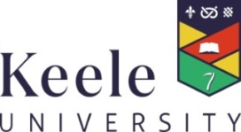

To be completed when considering new activities / business relationships

Brief Description of Activity

 | YES | NO * | N/A
If engaging with an individual - Appropriate identity checks have been made as to the identity of the third party. This may include:

Full Name and Address
Passport checks / visa documentation
Nationality
References

If engaging with an organisation – Appropriate checks have been undertaken on the business. This may include:

History of Trading
Reputational Issues
Companies House search
Vat Registration details
Financial Statements
Credit Check
References
Site Visits

University Procurement procedures have been followed where applicable

Appropriate division of duties has been considered as far as is possible / practical

If the activity is taking place overseas does this present any additional risks. If so have they been fully considered?

Has the University Hospitality Policy been adhered to? (Inappropriate gifts or hospitality should not have been offered to the University or its employees)

* If any of the questions have been answered “NO” then please provide an explanation below.

Additional Information

I have completed the risk assessment and have read and understood the University’s Anti-Bribery Policy.

Signature
Print Name
School / Faculty / Directorate / Unit
Date

Please keep a record of any completed risk assessments in your School or Directorate Office. This documentation may be required for internal audit and / or in the event of an investigation under Section 7 of the Bribery Act 2010.

Please also keep a copy of this form attached to any contractual documents for future reference.

